- Structural Equation Models (SEM) for relationship between pain and PTSD and Sleep

Outcomes: PTSD symptom severity (measure= PCL-5 total score)
pain ()

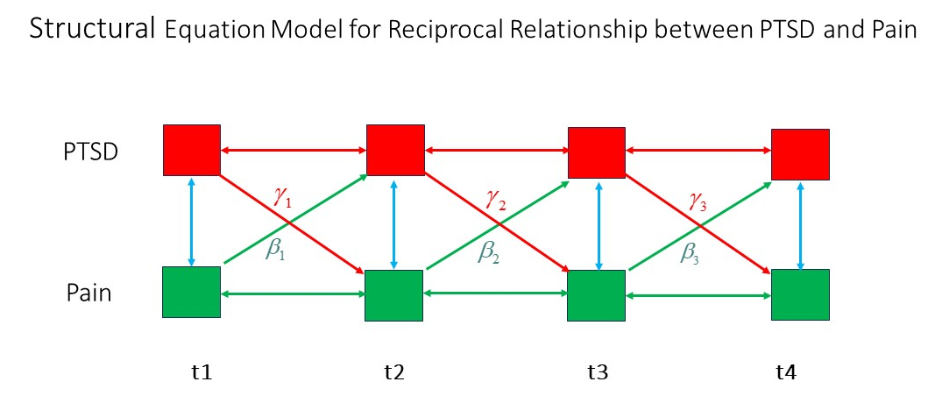

We are interested in coefficients (β and γ) and p-values for the single green and red arrows, NOT the bidirectional arrows.

